Communication and Language |  | Personal, Social and Emotional Development |  | Physical Development
-Hobbies:Describe some events in detail  - Hobbies: To engage in Non fiction books  - Retell the story, once they have developed a deep familiarity with the text, some as exact repetition and some in their own words.  -Engage is story time. Key texts –  - Guess how much I love you,  - Large family  - Love monster  - Scarecrows wedding  - Love umbrella  Poems and songs –  - You are my sunshine,  - Love is important by Jean Kay.  Treasure box -using full sentences, including use of past, present and future tenses and making use of conjunctions, with modelling and support from their teacher. |  | -How to love ourselves- Healthy diets/teeth hygiene  -How things your love makes you feel:  - Identify and moderate own feelings socially and emotionally.  • Think about the perspectives of others.  See themselves as a valuable individual.  • Build constructive and respectful relationships.  • Express their feelings and consider the feelings of others. |  | -Begin to show accuracy and care when drawing  - Family representations  • Hold a pencil effectively in preparation for fluent writing – using the tripod grip in almost all cases- Handwriting lessons.  -Responding to music  - Move energetically, such as running, jumping, dancing, hopping, skipping and climbing.
Literacy | Mathematics |  | Understanding the World |  | Expressive Arts and Design
•Valentines cards  - Write short sentences with words with known letter-sound correspondences  - using a capital letter and full stop.  - Re-read what they have written to check that it makes sense.  -Anticipate key events in stories | -Hearts patterns painting  -Comparisons of size between objects  (treasure box). |  | -Talk about members of their immediate family and community. • Name and describe people who are familiar to them.  - Comment on images of familiar situations in the past  - Compare and contrast characters from stories, including figures from the past  Draw information from a simple map – Chinese New Year  • Describe what they see, hear and feel whilst outside- What is love – wonderful world. |  | - Listen attentively, move to and talk about music, expressing their feelings and responses.  -Watch and talk about dance and performance art, expressing their feelings and responses.  -Explore and engage in music making and dance, performing solo or in groups.  -Junk modelling – Animals we love  Clay model heart – A gift for someone else.
Vut out
Wee

English key texts:
Weirdo – Zadie Smith
Nick Laird
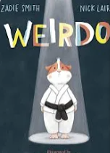

Autumn 2 phonics progression:
ow oi ear air ure er
Read: are, my, her,
Three (Mastery)

NCETM Maths:
Composition and comparison
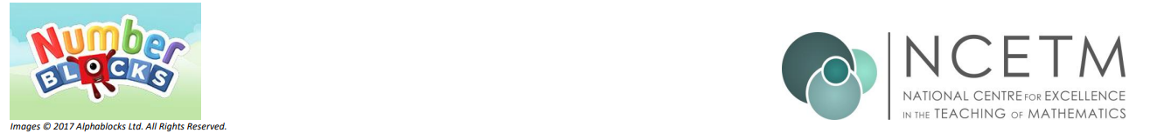

Open the doors with Little Pips
Valentines
11/2/2025

DT-Junk Modelling
RE- Special places
Music- Music and Movement.

PE- Gymnastics and speed Agility/travel.

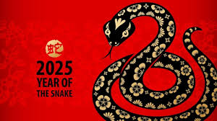
C
https://www.bbc.co.uk/cbeebies/watch/my-first-festivals-chinese-new-year

https://www.youtube.com/watch?v=dh7LJDHC

Can you explore who is in your family tree?
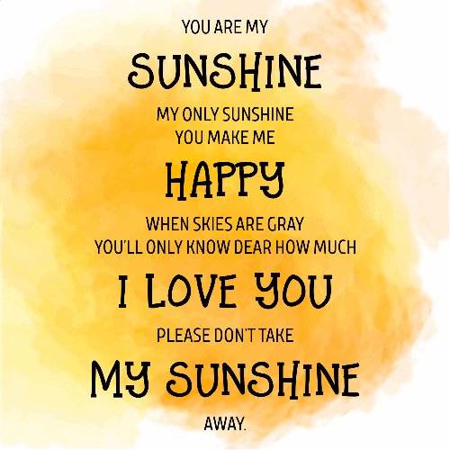
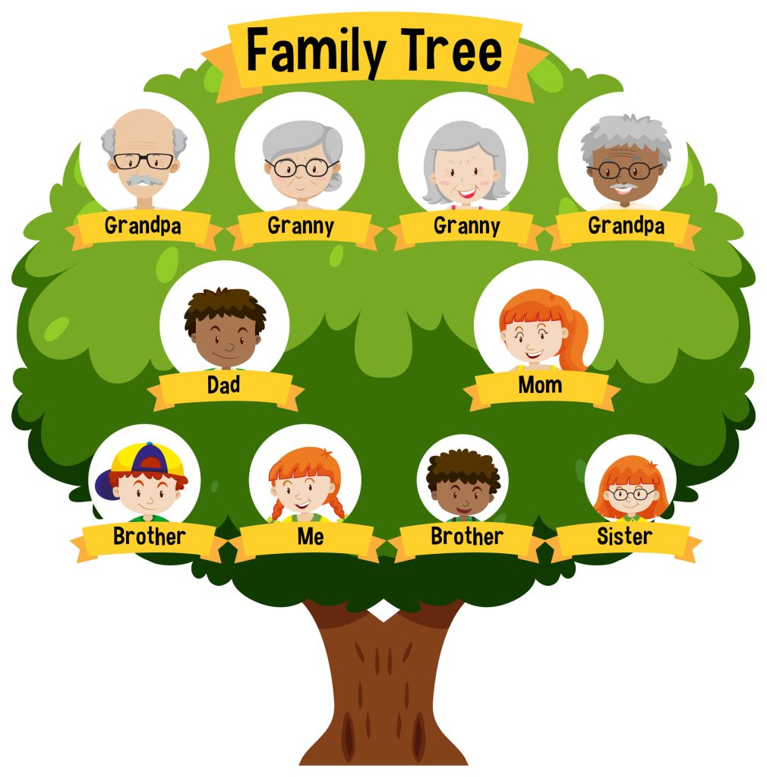
Love is a positive attitude towards someone or something. It means that you like it. And you enjoy playing, communicating, or doing something else with a person or thing
https://www.youtube.com/watch?v=dh7LJDHFaqA
Poem
https://www.youtube.com/watch?v=78-K_Wbp0pM

