Communication and Language |  | Personal, Social and Emotional Development |  | Physical Development
- To ask questions of what happened in past events- e.g Christmas story/Guy Fawkes.  - Using connectives to speak about celebrations  - To use speech to solve problems- e.g present surprise box  “I think it could be,  - Acting out a key story/event  -listen/sing Christmas songs/rhymes. |  | -Complements of others work to celebrate achievements.  - tell others about family’s celebrations  -Talk about the perspective of others in a story- Remembrance Day. |  | -Movement to how we feel.  -use scissors to cut out shapes for Christmas  -building a grotto  -I can write my name in Christmas cards  -I know why sleep is important
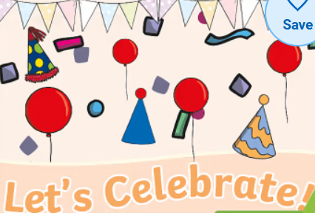
Literacy | Mathematics |  | Understanding the World |  | Expressive Arts and Design
-Doh disco to Christmas songs making own actions  -Mark make – fireworks following instructions in where to start letters.  -Capital letters for names Christmas party invites. | - Using shapes to create the festive objects.  - Count 10 objects to decorate a tree  - Dice rolling movement dancing to music.  - Count in 10’s for fireworks to go bang.  - Length – present ordering |  | - Family photos- looking at own celebrations- past and present  - Senses outside our local environment and place we live- looking at seasonal changes.  - Celebrations of others – Diwali- questions and places of worship.  - Write Christmas cards for staff members saying thank you.  - Where I live and where Santa will visit. |  | Create team art work- wreaths  Nativity performance sing and dance in tune and in sequence.  Watch a show and discuss it.
Vut out
Wee
Autumn 2 phonics progression:
Phase3 j,v,w,x,y,z,zz,qu,ch,sh,th,ng,ai,ee,igh,oa,oo,ar,or,ur
Words ending in ing
Trickywords: : go,me,we,be,he,she,was,you,they and all.

Open the doors
Christmas Party
19-12-24
RE: Nativity PHSE: Self image Music: Nativity

English key texts:
Hallibut Jackson
Oi Frog

NCETM Maths:
Number blocks


- Replace title (keep title and footer pink)
- Change images to pngs relevant to new topic
- Keep the headers and colours as they are (they use the EYFS specific colours for the areas of learning)
- Replace bullet points with text from teacher content. Hyperlinks within the bullet points should be bold, blue and underlined.
- Try to keep content to 1 page (ask Lucy if unsure to do this)
- Delete this instructions box

