Communication and Language |  | Personal, Social and Emotional Development |  | Physical Development
-Family tree who’s in my family circle time  - Pets pictures  - Class room friends guess who, asking questions of others.  -Senses, likes and dislikes. |  | -Valuable self, people close to us, cultures and family.  - I like to – children to perform own talent show  -Bring in and celebrate own outside achievements.  -The human body create junk modelling robots discussing how to look after them. – Hygiene and food. |  | -My body- gross motor skills. Learning about parts of the body.  - Calm and reflective time, to think about achievements of the day.  -Being safe, using tools such as scissors carefully.  - Team building games- e.g cross the river helping each other across.


All About Me
Literacy | Mathematics |  | Understanding the World |  | Expressive Arts and Design
-Doh disco- making a face out of playdoh.  -Mark making, my family  -Listen to stories and comment on how every family is different.  -segmenting actions to complete senses surprise box. | - Using shapes to create the human body.  - Measuring using cubes, feet size and leg/ Arm lengths.  - Sharing quantities between friends.  - Subsidising family members. |  | - When I grow up discussing timeline of growth. Baby till now discussing the past  - Family photos.  - Discuss feelings and experiences of showing kindness, bravery etc.  - Senses outside our local environment and place we live. |  | Draw Self-portraits using mirrors.  Feel good through music.  Talents and self confidence in performing  Role play home corner.
Wee
Autumn 1 phonics progression:
Phase2: s,a,t,p,i,n,m,d,g,o,c,k,ck,e,u,r,h,b,f,ff,l,ll,ss
Words ending in s
Tricky words : the, to,into,no, I ,go.

Open the doors
Senses stations
With Little Pips.
WC 14.10.2024
RE: Special me and Special times. PHSE: Online safety
Music: Exploring Sound Computing: BAREFOOT- Busybodies

English key texts:
Hairy Maclary from Donaldson’s Dairy- Lynley Dodd
Bringing the Rain to Kapiti Plain- Verma Aardema

NCETM Maths:
Number blocks
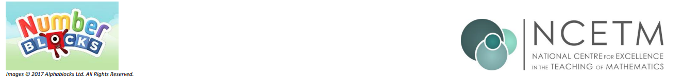

- Replace title (keep title and footer pink)
- Change images to pngs relevant to new topic
- Keep the headers and colours as they are (they use the EYFS specific colours for the areas of learning)
- Replace bullet points with text from teacher content. Hyperlinks within the bullet points should be bold, blue and underlined.
- Try to keep content to 1 page (ask Lucy if unsure to do this)
- Delete this instructions box

