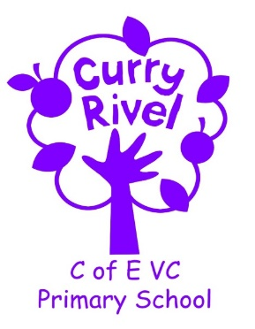

Lunchtime Supervisor Vacancy (MDSA)

We are looking for a lunchtime supervisor to join our team and work with a child with special educational needs (medical).

We are a friendly, committed and supportive team and you would be warmly welcomed into our school community.

The lunchtime supervisor role is very rewarding - supporting children at the mealtime, encouraging children with the various activities and overseeing everyone’s wellbeing. You would work within a team of 6 people and be given information and training to support you in the role of working 1:1 with a child. The times would be from 12 to 1pm (term-time only) starting at SCC Grade 16 point 2 which is equivalent to £18,198 pro rata and £9.45 per hour.

All positions in school would require a criminal background check via the Disclosure Procedure as we are committed to safeguarding our children.

Please contact Mrs Ali Pook or Mrs Helen Davies if you would like to visit the school or would like any further information (01458 251404) or by email curryrivelprimary@educ.somerset.gov.uk. We look forward to hearing from you. Applications close midday Friday 19 March 2021.

