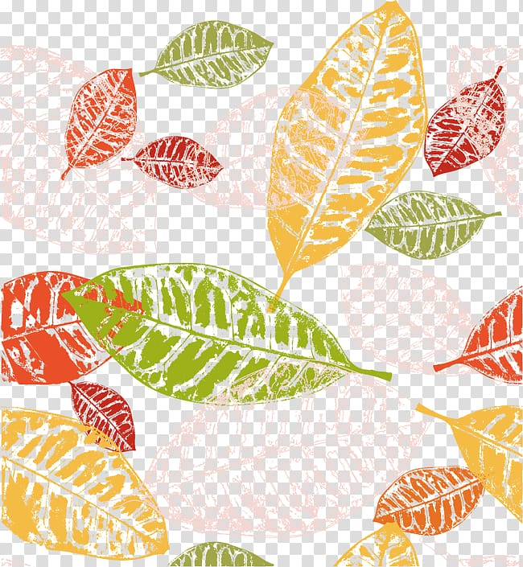

“Wonderful me “

Autumn one

Main Nursery