Little Pips Nursery
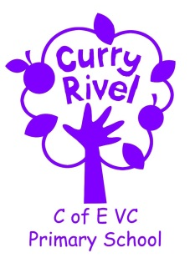

Information and Ideas
for your child’s next steps
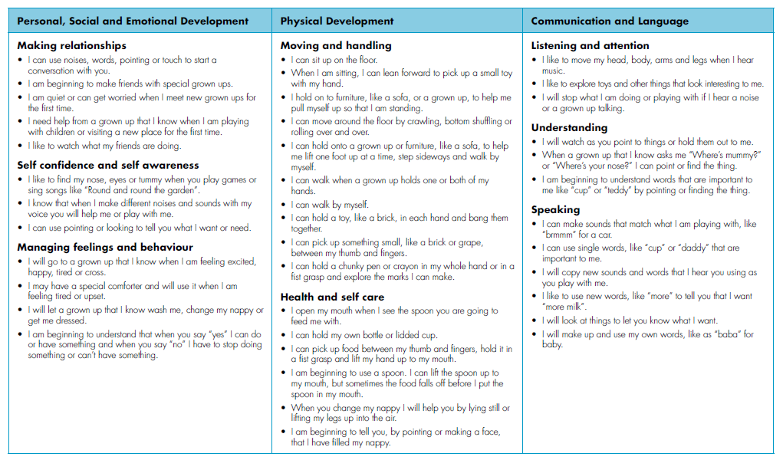
The Early Years Framework explains the next steps that a child will take at each stage. Each individual child develops different strengths at different times and this booklet will help clarify what might happen next as your child progresses.
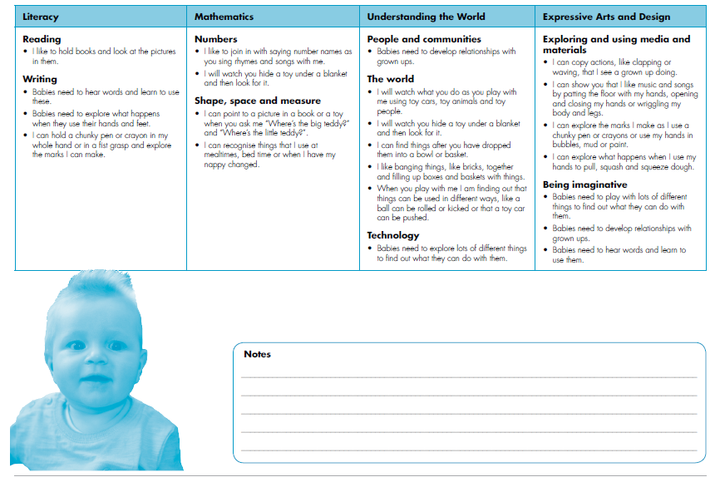
Expressive Arts and Design
Exploring and using media and materials
- Let me use my hands and feet to find out what marks I can make with paint or to make bubbles pop.
- Make sock puppets move to music or songs as you sing to me.
Being imaginative
- I need to play with lots of different things to find out what I can do with them: scarves, boxes, rattles, safe mirrors.

Personal, Social and Emotional Development
Making relationships
- Share photos of special grown-ups with me.
- Let me meet special grown-ups. Tell me their names.
Self-confidence and self-awareness
- Let me look in a mirror. Point to me and tell me what it’s me in the mirror. Point to my nose, arms and legs and tell me what they are.
Managing feelings and behaviour
- Let me get my comforter or special toy when I’m feeling sad or tired.

Communication and Language
Listening and attention
- Share stories with me at bedtime or when we’re snuggled up on the sofa.
- Sing songs to me when you’re getting me dressed or changing my nappy.
Understanding
- Hold my hands to help me make the actions as you sing songs.
Speaking
- Tell me the names of things as I pick them up to explore.

Understanding the World
People and communities
- I need to develop relationships with grown-ups. Introduce me to people when we are out and about.
The world
- Play “hide and seek” games where I have to find one of my toys.
Technology
- Give me different objects to explore: pots, pans, spoons, paper.

How you can help your child…
Physical Development
Moving and handling
- Let me splash my hands and kick my feet in the bath.
- Give me a doll’s buggy or trundle trike to push.
- Put my favourite toys on the floor so that I can crawl or bottom shuffle to them. Move them further away to give me a small challenge.
- Let me lift the flaps in a board book and share my excitement in what is behind the flap!
- Give me dough so that I can squeeze or squash it with my hands or poke it with my fingers.
- At feeding, changing or bath times share finger play songs with me like “Round and round the garden”
Literacy
Reading
- Let me hold the book as you share the story with me.
- Talk to me about what is happening in the pictures or who you can see in the pictures.
Writing
- Give me chunky pencils/crayons/chalks to play with
Mathematics
Numbers
- Let me explore a treasure basket with different things in it, like a collection of different types of spoons or a collection of shiny things.
- Sing number rhymes to me, like “Two Little Eyes to Look Around”.
Shape, space and measure
- Let me explore different things to see what I can do with them, like a collection of different types and sizes of balls or things that will roll.

