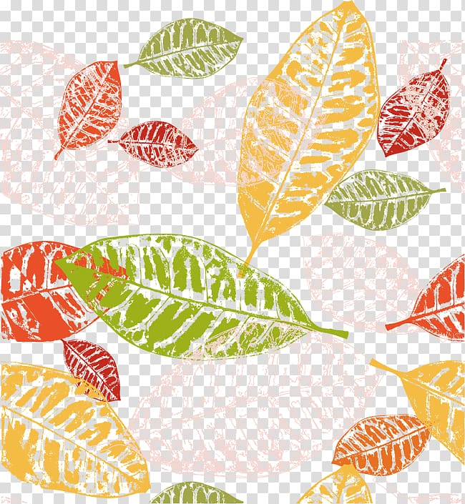

‘Wonderful Me’

Autumn One

Baby Room