Little Pips Nursery Prospectus 2018/2019
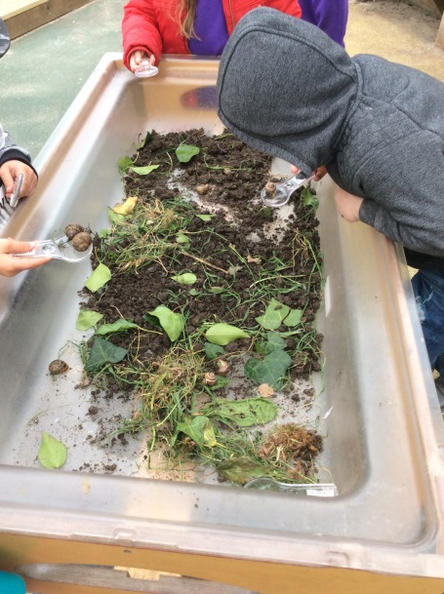

Church Street
Curry Rivel
TA10 0HD
Tel: 01458 252822

Welcome to Little Pips Nursery
Introduction
Little Pips is part of Curry Rivel Primary School and our aim is to provide an excellent environment for your child; nurturing care, creative experiences and lots of fun. We are fortunate enough to have a spacious building with well-equipped indoor and outdoor areas. The extensive grounds of the school give us great opportunities to explore outdoors, particularly in the forest school area.
Key Features of the Nursery
- A warm welcoming atmosphere
- High levels of professional practice with well qualified and experienced staff
- A strong partnership with Curry Rivel Primary school staff to ensure excellent transition and support for children and families
- Close liaison with parents/carers to share knowledge and needs of the child
- A key-person system giving consistency and building relationships during the child’s time at Nursery
Aims and Objectives
We aim to provide a happy secure and stimulating environment for parents and their children attending Nursery. We value close co-operation with parents and work with them as partners in their child’s development and always seek ways to actively involve them.
Our Nursery is organised with an emphasis on early intervention. The Nursery is a place where we strive to help the whole family- our aim is to provide a safe place for families, where new experiences and opportunities are offered and lots of fun is had along the way!
Equality and Diversity
Little Pips Nursery believes in promoting children’s rights and offering equality of opportunity, whilst respecting an individual’s right to be different.
We value and welcome children and families from every cultural, social and religious background and we respect the different structures of families and lifestyles.
Nursery Education Funding
Somerset County Council currently funds 15 hours of Nursery education for three and four year olds starting from the funding period after your child’s third birthday. Some children may be eligible for 2 year funding support, depending on a family’s financial circumstances. 30 hours of funding is also available to those eligible. Please see the Nursery Manager or Nursery Administrator for more information about funding details and how they can be accessed.
Data Protection
Your personal information will be held and used in accordance with the Data Protection Act 1998. Personal data relating to individuals will be stored securely and only used for legitimate purposes. We will not disclose such information to any unauthorised person or body.
Little Pips Opening Times and Fees
Little Pips is open from 7.30am until 6.00pm, Monday to Friday (Excluding bank holidays). We are open 50 weeks per year, and only close for two weeks at Christmas. We offer children and families either a term-time only or an all-year-round space; please speak to our Nursery Manager for further details.

Session | 0-2s (£4.75 per hour) | 2-3s (£4.50 per hour) | 3-4s (£4.25 per hour)
Breakfast 7.30am-9.00am | £3.50 | £3.50 | £3.50
Morning session  9.00am-12.00pm | £14.25 | £13.50 | £12.75
Afternoon session 12.15pm-3.15pm | £14.25 | £13.50 | £12.75
Core session 9.00am-3.00pm | £28.50 | £27.00 | £25.50
Additional hours after 3.00pm  (Charged in half an hour blocks) | £2.38 per additional half an hour | £2.25 per additional half an hour | £2.13 per additional half an hour
Please note our fees include snack, but do not include lunches.
Lunches
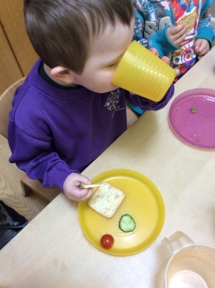
Our lunches are provided by BAM; freshly cooked and delivered to our school. Lunches cost £2.50 per day and can be booked on a daily basis during term-time only – Menus are displayed in both Nursery rooms.

Starting Nursery…….
Settling in
Our Nursery Manager will discuss with parents/carers a set of suitable dates to settle into Nursery.
Arrival and Home Time
Please use the relevant buzzer when arriving at Nursery and wait for a member of Nursery staff to let you into the building.
What to Wear
In order to feel free to explore our environment and experiment with all kinds of materials, including messy ones, it is best to send children dressed in clothes that are comfy and easily washable. Nursery jumpers are available from the main school office .The paint we use can stain. The manufacturers recommend a warm NOT hot wash.
It is good for children to practice skills which will make them independent. Simple clothing, which they can handle themselves, will enable them to go to the toilet when they want to and to put on and take off their outdoor clothes without being too dependent on others people’s help.
Please ensure EVERYTHING is labelled with your child’s name including coats, hats, bottles, bags etc …
Key Person
Our key person system gives staff responsibility for a group of children. The key person is in a position to tailor the child’s/groups experience to the unique needs of each individual child. The key-person maintains links with the child’s parents through informal chats and shared record keeping, to ensure that children are supported in reaching their full potential.
Nursery Areas
The Nursery has two spacious rooms as well as an outdoor areas for each room. We also have access to forest school.
The Nest
The Nest is for children who are 0-2 years. The Nest is a purpose built room designed to be bright, airy and relaxed. The Nest has its own spacious outdoor area, sleep room, kitchen and changing facilities .The staff work closely with parents to ensure the transition from home to Nursery is as smooth as possible. For those children aged under 2, a record of daily activities is sent home at the end of each day.
Main Nursery
Children can start within the main Nursery at 2 years old and all children flow freely inside and outside, completing activities and developing experiences from their own interests.
Quality Early Years Curriculum
At Little Pips, we offer a rich, secure and supportive multi-sensory play environment, where children can learn both indoors and outdoors, with enjoyment and challenge.
We follow government legislation outlined in The Early Years Foundation Stage (EYFS). This document combines care and learning under four themes:
- A Unique Child
- Positive Relationships
- Enabling Environments
- Learning and Development
There are 7 areas of learning and development,that are all important and all interconnected.
Three areas are particularly crucial for igniting children’s curiosity and enthusiasm for learning, and for building their capacity to learn, form relationships and thrive.
These three prime areas are:
- Personal , social and emotional development
- Communication and language
- Physical development
The four specific areas, through which the three prime areas are strengthened are applied, are:
- Literacy
- Mathematics
- Understanding of the World
- Expressive arts and design
Learning and development across all of these areas are underpinned by the characteristics of effective learning:
- Playing and exploring
- Active Learning
- Creating and thinking critically
Staff follow a continuous provision plan that provides coverage of the Early Years Foundation Stage curriculum. Each key person observes the learning needs and interests of the children and plans to provide resources and experiences (both inside and outside), that will support, extend and challenge each child’s development.
Every week, a balance of child initiated and adult led activities and experiences are observed and evaluations are made of what the children are doing, how they are doing it and what should be provided to support their next steps.
Throughout the Nursery day, your child is very busy creating unique masterpieces in all areas of Nursery. Sadly, not all of these can be taken home and so we make observations, take photos and keep examples of their work they create to give you an insight into your child’s day at Nursery. You are welcome to have a look at these, in your child’s ‘Learning Journey’.
A Special Reminder
Parents play the most important role in educating a child from birth . Your support and positive attitude to learning is key to your child’s success and learning. Talking to your child about the world around them and how they are feeling will help them progress.
Lunches
Our lunchtime is between 12.30-1.15pm. We are able to offer a hot lunch during term-time; alternatively you can send a packed lunch with your child. We ask you to not provide sweets and fizzy drinks with your child’s packed lunch. We are able to heat jars and pouches for babies, but will not re-heat pre-cooked meals from home.
Information and hand-outs on Healthy Eating are available in the main reception.

Sickness and Health
Please do not send your child to Nursery when he /she is obviously ill
- A child suffering from sickness and diarrhoea should not come to Nursery until he/she has been clear for a full 48 hours
- A child known to have head lice must not come to Nursery until lice have been treated
Should we feel your child is too unwell to be at Nursery we will contact you to collect your child.
First Aid
Any child who is taken ill during the day, or who suffers a minor accident, will be cared for by our qualified First Aiders. Parents will be contacted immediately, if we feel the child should be sent home or requires further treatment.
Special Needs
We believe in providing the best possible provision for children of all abilities .The number of adults present in the Nursery enables us to cater for the individual needs of each child and we follow the ‘graduated response’ recommended in the Somerset’s Code of Practice ( see SEN policy). This means that each child is able to progress at his/her own rate in all areas of development and we are able to provide appropriate activities through play. At different stages in your child’s life, it can be useful to have input from expert advice. We are experienced at working in close liaison with professionals across the range of special needs and we benefit from multi-agency working. If you would like to discuss how we can best meet your child’s needs, please talk to:-
- Hollie Westlake – Childcare Manager
- Jenifer Oliver – Nursery SENCO
- Joanne Ward – SENCO Teacher
Safeguarding
If you have worries about the safeguarding or well-being of any child, please contact the safeguarding / child protection Lead, Hollie Westlake or Joanne Ward (Curry Rivel Primary School). Alternatively, you can call Somerset Direct on 300 123 2224.
Concerns or Complaints
We would ask you to come in whenever you have a concern regarding your child, so that we can discuss the matter. In the first instance, you may want to discuss the matter with Hollie Westlake. If you have a formal complaint, it should normally be made to the Head teacher. It is hoped that in most cases, complaints will be dealt with at this informal level.
However, if the complaint cannot be resolved with the Head teacher, the parent should submit his /her complaint in writing to the clerk of governors. The clerk will acknowledge receipt of the complaint and inform the governing body. Ofsted may also be contacted.
And Finally…
In this prospectus, we have tried to cover most of the information that you may need when your child starts Nursery. Do feel free to call in or telephone, if you have any queries. We look forward to you joining us.

