It has been wonderful to welcome everybody back to Nursery.

Across both rooms we will be exploring Autumn and the change in seasons. In the main Nursery we are focussing on developing independence. You can help support this at home by encouraging your child to help with dressing and undressing, using cutlery, drinking from an open cup and opening up food packets independently.

At Nursery we use ‘The Magic Coat Method ‘, so many of you have been asking about it so I have added a step-by-step guide below.
Step 1 – Lay the coat on the floor and kneel at the hood

Step 2- Place arms in arm holes

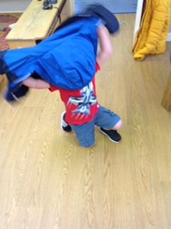
Step 3- Flip the coat over your head

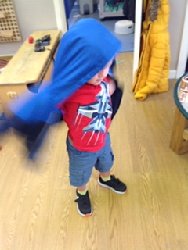
Step 4- ‘TADA’ Your coat is independently on!

A new face ……

From next week we have a new face joining us until December.
Jessica McCreery joins us an Early Years Trainee teacher and will be working within the Main Nursery.
Jessica has a BA Hons in Early childhood studies and has spent the past two years working within Kindergartens in Germany.

Children starting school in September 2021- Please remember to follow the link here to apply for your child’s school place https://www.somerset.gov.uk/education-and-families/apply-to-start-school
A few reminders regarding our new COVID related routines and procedure
Children should arrive to Nursery having had breakfast at home unless they are booked in for a 7.30am start with us
Please provide one piece of fresh fruit, salad or vegetables for snack only, please do not send raisins or other dried fruit
Children having packed lunch must also have a piece of fresh fruit, salad or vegetables in their lunchbox too
We have a child with a severe egg allergy at Nursery, you may still send egg products but please notify a member of staff at drop off that your child’s lunchbox contains a whole egg item
Please remember to queue on the pavement for drop-offs and collections
9.00am is our busiest drop-off point, please ensure you arrive promptly at this time, as the weather changes we do not want to hold large numbers of children whilst we await late arrivals. If you arrive after 9.10am without prior arrangement you will be asked to wait until 9.30am to drop-off whilst staff sing our morning ‘hello’ song and get children settled into their morning activities

Christmas close down
Nursery will be closed from Friday 18th December until Wednesday 6th January

Appropriate clothing …..
Please ensure you only send your child to Nursery in clothes that you are happy to get messy as we provide a range of activities throughout each session.
Our children have access to the outdoors whatever the weather so children must arrive with a warm, waterproof coat as we move towards the colder months.

Nursery is a fun but messy place ……
Please only send your child to Nursery in clothes they are fully able to participate in activities in. We cannot guarantee your child will come home clean but we can guarantee they will have fun.

We have been busy developing our area of the school website.
You will be able to find copies of the hot lunch menus, our current planning and ideas on how to support learning at home by clicking on the ‘Nursery’ tab.

