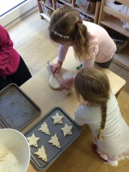
Dear Parents,
What a busy year we have had as the Nursery continues to grow. We have been completely overwhelmed by all of your kind cards, gifts and messages over the Christmas period.
Thank-you to everyone who attended our Christmas Fayre on Tuesday, it was so lovely to see so many parents and grandparents all together having fun. We raised £337.00 to spend on resources for the children to enjoy, watch the website to see what we decide to purchase.
We would love to see photos of you enjoying Christmas at home, please email any photos in to either Lorrainne (lgill1@educ.somerset.gov.uk ) or Hollie (hwestlake@educ.somerset.gov.uk).
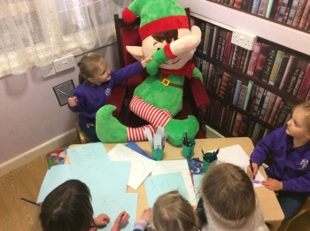
We will be holding an open-evening for all parents during January, this will be a chance for you to meet your child’s key-person, discuss your child’s development and ask any questions you may have. We will also be sending out a parental questionnaire to all parents.
Nursery will re-open on Tuesday 8th January 2019.
Merry Christmas

The Nursery Team x

