Geography  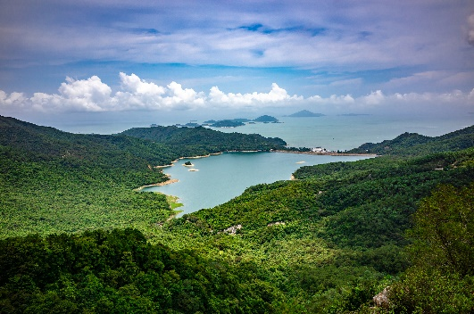 | What is Geography?  - Geography is a study of places.  - You research and learn about how people interact with their environments.  Why is Geography so important?  - Geography helps us to learn about how and why our world is changing.  - It develops decision making and investigation skills.  Which careers are linked to Geography?  Researcher, teacher, environmental consultant, weather forecaster, globemaker, conservationist, volcanologist, geologist, town planner, tour guide, heritage site manager, diplomat, aid worker.
Core Concepts  - Land use and Settlements  - Climate and Weather  - Coasts, Rivers and the Water Cycle  - Lifestyle, Economy and Trade  - Sustainability and Resources  - Physical Features and Processes | What are the areas of Geography that I will learn about?  - Place Knowledge  - Locational Knowledge  - Human and Physical Geography  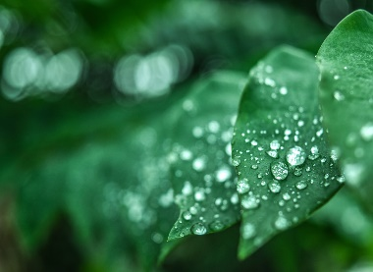 | What are the Geography skills that I will learn?  - To investigate places  - To investigate patterns  - To communicate geographically  - Fieldwork experiences

