Weekly Update: 1st October 2021
Dear Parents/Carers,
Incredibly, it is October already and autumn seems to have begun overnight! Although it is with sadness we say goodbye to the summer, autumn is a wonderful season which I’m sure we all enjoy in different ways. And with the season comes Harvest; the children have heard from Ginny Smith this week, about the important work of the Curry Rivel Foodbank. Ginny explained that any foods donated at the Harvest Festival on Tuesday will be gratefully received and this includes fresh foods such as bread, fruit and vegetables- dried goods will also be welcomed. Rev Matt Cottingham, the Fivehead Baptist Minister, reinforced the children’s learning in Collective Worship about the importance of being thankful and to be generous at this special time.
Medical Care Plans
Please return your child’s medical care plan if you have not done so already.
Isabel Haigh: GB Gymnast
Hopefully you have seen the photos on our Facebook page of the visit by Isabel a GB gymnast- this was a very inspiring visit and has hopefully motivated all of our pupils to ‘aim high’.
Subject Spotlight: Design Technology
This half term, Year 1 pupils in Pippin, Camelot class Blenheim class are having weekly DT lessons- other classes’ DT lesson will follow after half-term.
What is DT?
- DT is an inspiring and practical subject.
- You design and make products that solve real and relevant problems.
Why is DT so important?
- You learn how to take risks, becoming resourceful, innovative, enterprising and capable citizens.
- You develop understanding of the impact of DT on daily life and the wider world.
Which careers are linked to DT?
Graphic design, architecture, fashion, media, engineering, construction, motor industry, robotics engineering, game design

What are the DT strands learnt?
- Cooking and nutrition
- Mechanical systems
- Textiles
- Electrical systems
- Structures
- Digital world: Programming
What is the design process?
Design. Make. Evaluate. Improve
So what are the children saying?
“DT is designing and making” Year 6
“Programming, textiles and food” Year 6
“Last year we made cars” Year 6
“I really like DT as we get to taste the food and it was fun choosing ingredients” Year 6
“I have learnt new skills like using a knife and how to prepare.” Year 5
“In DT, you design and make things likes bridges and structures.” Year 5
“We have had 3 or 4 lessons and used triangles to make a truss to make the bridge strong.” Year 4
“You can be an engineer. You can learn techniques in other jobs too.” Year 5
“I am interested in this as a job.” Year 4
Impact of the curriculum
- Children know some of the DT processes and strands.
- They know how this is linked to primary futures.
- They have some sticky knowledge.
- They have learnt technical language
- They have developed skills E.g. Cutting with a knife, using an oven, making trusses
- Making children think of their future

Message from Huish Academy: Parent Workshops
Venue for all sessions: H1, Huish Sixth Form, Huish Episcopi Academy, Langport, TA10 9SS
We are pleased to be able to offer these sessions again, they are useful for parents, governors and school staff. Please book your place online.
Child Exploitation by County Lines
With Escapeline
Monday, 8th November 2021
Starting at 6:30pm, estimated end time 8pm
In the South West of the UK, including all areas of Somerset, there is a significant rise in county lines drug crime, whereby a large amount of young people as young as 10 years old, are being criminally and sexually exploited by gangs. County lines are illegal business models, in which drug gangs expand their operations from their big city bases, such as London, Birmingham and Liverpool, to smaller cities, towns, coastal and rural areas across Britain. These gangs use their power and position to groom, recruit and exploit children and young people for the purpose of criminal gain.
These gangs proactively recruit young people to drug run in and around the South West, as well as outside the area. The gangs and criminal networks use extreme violence and intimidation towards these young people, which result in these young people feeling trapped and scared. Some of these gangs are forcing vulnerable children from their homes to be trafficked to other parts of the country. As well as criminal exploitation, young people, both girls and boys, are also being sexually exploited by these gangs.
This session will raise awareness of the signs of Child Exploitation by County Lines and guide you in teaching children and young people about healthy relationships.
To book a place to attend this session please visit: https://forms.gle/592rtyxWEWAysouq9

Children’s Well-being and Mental Health
With NHS Somerset Mental Health Support Team
Monday, 6th December at 6:30pm, estimated end time 8pm

Mental health problems affect about 1 in 6 school-ages children and 50% of all mental health problems start by the age of 14.
This session will help parents/guardians/carers promote good mental health, wellbeing and resilience, supporting children’s physical health, positive relationships and education.
To book a place to attend this session please visit: https://forms.gle/zzmfE994hfGYUrby5
Behaviour Management Techniques
With Family Solutions Somerset
Monday, 24th January at 6:30pm, estimated end time 8pm
A whistle stop tour of some parenting techniques and strategies to use with your children aged 2-18.
We will be looking at the following principles that underpin all areas of parenting (and relationships) whatever the age.
- Emotion Coaching, being able to label our emotions- CBT/Behaviour Curve
- Showing empathy not sympathy
- Attention – children will seek any kind of attention – good or bad
- Ignoring behaviours we want to see less of
- Specific praise… labelled
- Social Learning Theory – new behaviours can be learnt by observing and imitating others (bandura)
- Use of rewards – after the event (bribes come before), smart and cheap
The session will be fully collaborative, and we will be open to conversations and listening to your own techniques which have been successful.
To book a place to attend this session please visit: https://forms.gle/9jR8M5hDZNnQnvTm8
Growth Mindset
SCC Educational Psychologist
31st January 2022 at 6:30pm, estimated end time 8pm

The beliefs children have about intelligence, effort, and struggle impact the choices they make about learning. Children with a fixed mindset believe that intelligence is fixed at birth and doesn’t change with practice. They see school as a place where abilities are evaluated and they interpret mistakes are a sign that they lack talent.
This session will help you help your child/ren to develop a growth mindset believing that intelligence can be developed. These students see school as a place to develop their abilities and think of challenges as opportunities to grow.
To book a place to attend this session please visit: https://forms.gle/9cvon4GwrC3ChTaaA
Dyslexia Awareness
With Mark Long, SCC Lead Advisory Teacher
Monday, 28th February 2022
Starting at 6:30pm, estimated end time 8pm
Dyslexia is a learning difference that affects 1 in 10 people. Individuals with dyslexia often find it challenging to develop reading and spelling fluency and can also have difficulty with remembering verbal instructions and learning sequences such as the alphabet, days of the week and times table facts.
This session provides an introduction to dyslexia. It explains why children with dyslexia can find reading, spelling and writing so challenging and describes strategies that can be used to help children improve in these areas.
To book a place to attend this session please visit: https://forms.gle/ewtp83j8RhP53MLU7
Online Safety & Social Media
With Amy Brittan, SCC Education Technology Advisor
14th March 2022 at 6:30pm, estimated end time 8pm
New technologies inspire children to be creative, communicate and learn. But with the digital world changing all the time, how can you make sure your child’s staying safe?
This session will provide parents/guardians/carers with information to support their children to enjoy technology safely and responsibly. You will have the opportunity to think about what you want to do to protect your family and to equip them for their future.
To book a place to attend this session please visit: https://forms.gle/Qt4Dxmbjb4KVME377

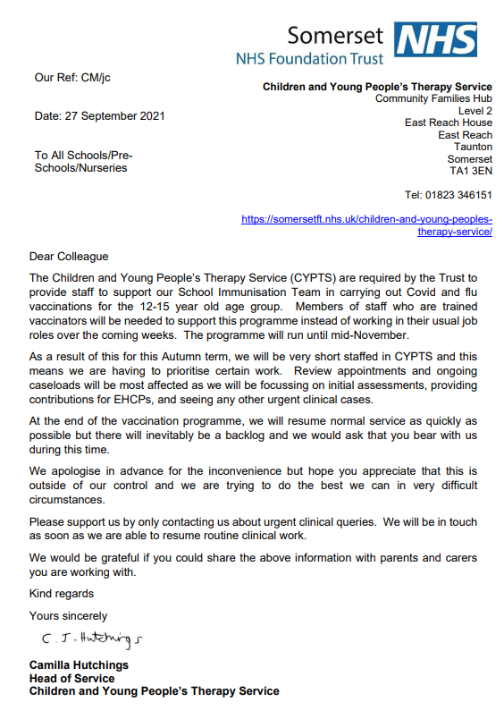

Safeguarding

- It is vital that any concern you have for a child’s welfare, however small is recorded and passed to our Safeguarding Lead. The Designated Safeguarding Lead (DSL) is the Headteacher Mrs Ali Pook, the Deputy DSL is Mrs Jo Ward and Miss Hollie Westlake.
- All staff members at Curry Rivel Church of England Primary School have an important role to play in helping to identify welfare concerns and possible indicators of abuse or neglect at an early stage.
- If the Designated Leads above are not available or if it is out of school hours you should ring: Children's Services on 0300 123 2224
- Our Child Protection and Safeguarding Policy can be found on our website.
The following websites provided useful information relating to safeguarding children:

- http://www.anti-bullyingalliance.org.uk/
- http://www.stop-cse.org/
- https://www.nspcc.org.uk/
- https://kidscape.org.uk
- http://educateagainsthate.com/

Sports Teams
Congratulations to our netball and football clubs who attended tournaments this week- the football team won all their three matches and the netball team were successful in one game- a brilliant start to the season and the children were great ambassadors. Thank you to Mr Bridgeman, Mrs Hardwick and Mr Silver who have been coaching the children.
PE Lessons and Clubs
To keep children safe during physical activity, please can stud earrings not be worn on PE/club days- if they cannot be removed, we will carefully cover them with medical tape in order to avoid injury.
Running Engines
Please may I encourage all parents/carers who park close to the school to switch off their engines whilst stationary- many thanks.
Awards
It was wonderful to welcome parents/carers to our celebration assembly today. We are all so proud of the following pupils:

Class Cup Awards
Pippin: Millie
Maigold: Finley
Gala: Lily H
Discovery: Dulcie
Camelot: Kahleesi
Blenheim: Oscar
Lunchtime stars
Pippin: Noah
Maigold: Finley & Lily
Camelot: Akaisha
Blenheim: Oscar
Dates for your diary
Tuesday 5th October: Harvest Festival
Friday 8th October: Open morning for prospective parents
Thursday 14th October: Parent Teacher Association Annual General Meeting 7.00pm (Please contact the school office if you are attending so we can manage numbers safely). Tea, coffee and biscuits.
19th/21st October: Parents’ evenings
Friday 22nd October: INSET Day
25th- 29th October: Half term

Planning Ahead: INSET Days
The followed INSET dates have been agreed with the Governing board:
Monday 6 September 2021
Friday 22 October 2021
Tuesday 4 January 2022
Monday 25 July 2022
Tuesday 26 July 2022
Additional Day for the Queen’s Jubilee
There has been a change to the schools’ calendar for the academic year 2021 to 2022 to enable everyone to celebrate the Queen’s Platinum Jubilee Bank Holiday on June 3, 2022. As the additional Bank Holiday falls within the school holidays, there is an additional holiday day for community and voluntary controlled schools. The Board of Governors have agreed the following date as an additional day’s holiday: Monday 6th June 2022.
Well-being tip of the week
Be Conscious of Your Feelings: We don’t always like to confront how we really feel about things. We are often quick to sugar coat and gloss over our natural emotional response to people and situations.
Have a restful weekend.
Ali Pook
Head Teacher

