Little Pips Nursery
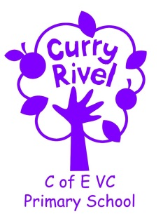

Information and Ideas
about your child’s next steps
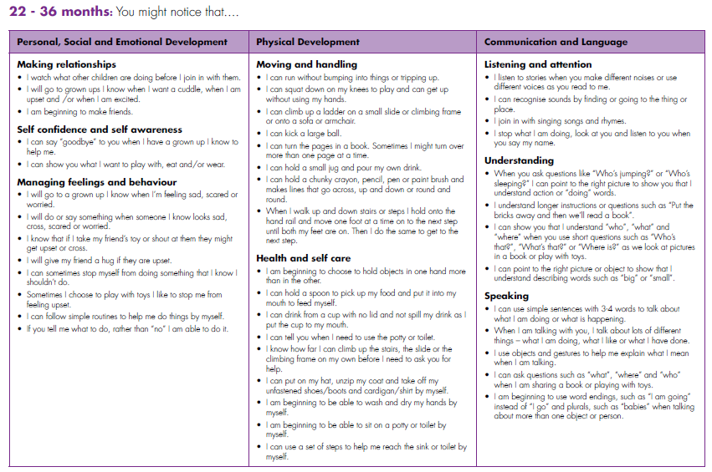
The Early Years Framework explains the next steps that a child will take at each stage. Each individual child develops different strengths at different times and this helps clarify what might happen next as your child progresses.
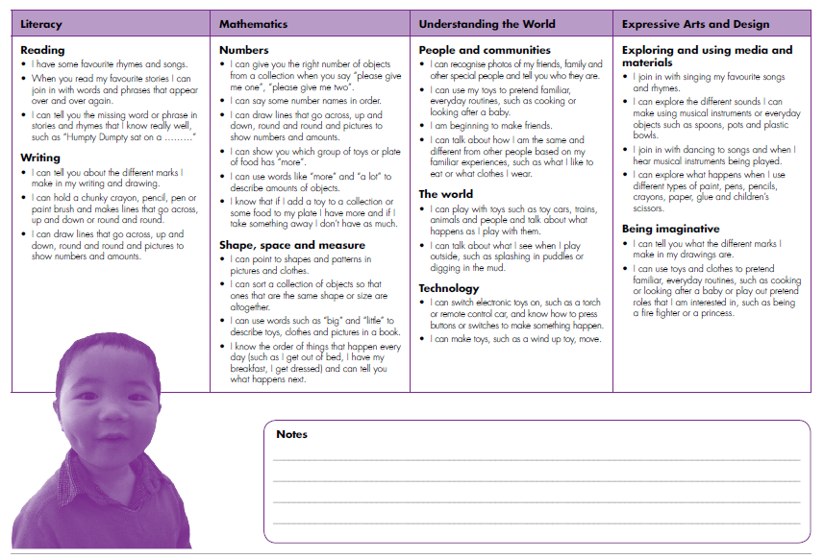
Physical Development
Moving and handling
- Play ball games with me.
- Give me lots of ribbons that I can wave around me.
- Let me try and dress my teddy or doll with different types of clothes, like coats, jumpers and dresses, and different types of fastenings, like buttons, Velcro and zips.
Health and self-care
- Let me help get lunch ready by cutting the cheese or bananas.
Personal Social and Emotional Development
Making relationships
- Make dens from sheets and blankets that I can play in with you or my friends.
Self-confidence and self-awareness
- Make a box with different things in it, like glue and different types of paper,that I can choose from when I’m making a picture or model from boxes.
Managing feelings and behaviour
- Talk to me about the order I need to do things in, like brushing my teeth or getting ready for bed.

Understanding the World
People and communities
- Let me taste food from different countries and cultures.
The world
- Let me explore bubbles, windmills or streamers when it’s windy.
- Let me use toy cars, buses or trains to make up stories about going to the supermarket, going on holiday or going to nursery.
Technology
- Let me press buttons on things like torches or remote control cars to see what happens.

Expressive Arts and Design
Exploring and using media and materials
- Let me explore the different sounds I can make with everyday things like spoons, pots and plastic bowls.
- Make a box with paper, glue, scissors and crayons that I can use to make pictures.
Being imaginative
- Let me dress up using grown ups’ clothes, pieces of fabric, hats and bags so that I can pretend to be somebody else.

Understanding the World
People and communities
- Let me taste food from different countries and cultures.
The world
- Let me explore bubbles, windmills or streamers when it’s windy.
- Let me use toy cars, buses or trains to make up stories about going to the supermarket, going on holiday or going to nursery.
Technology
- Let me press buttons on things like torches or remote control cars to see what happens.

How can you help your child?
Literacy
Reading
- Let me use my toys to help me tell you stories that we’ve shared.
- When you read me stories that I know really well, stop at different parts and let me tell you the missing word.
Writing
- Draw and paint with me and tell me what you’re doing.
- When you’re writing lists or filling in forms let me have my own paper or forms so that I can make my own marks.
Mathematics
Numbers
- Make skittles with me from plastic bottles. Play games where we have to keep a score of how many skittles we’ve knocked down.
- Sing counting rhymes with me like “Five Little Men in a Flying Saucer” or “1,2,3,4,5 Once I Caught a Fish Alive”.
Shape, space and measure
- Let me sort the clothes so that I put all the ones with the same pattern or colour like red, spotty or stripy together.

Communication and Language
Listening and attention
- Use sock puppets or toy people or animals when you’re sharing one of my favourite stories or songs with me.
Understanding
- When we’re making a sandwich together tell me what you are doing so I know what to do.
Speaking
- When we’re playing with things, use new words to describe what I’m doing with them or to tell me what they are called

