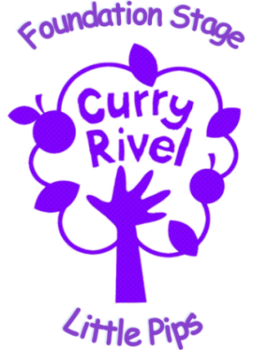

Admissions
It is our intention to make Little Pips accessible to children and families from all sections of the local community. We aim to ensure that all sections of our community have access to Little Pips through open, fair and clearly communicated procedures.

Our Nursery is;
- Open from 7.30am until 6.00pm Monday through to Friday
- Open for 52 weeks of the year , we always close for bank holidays and two weeks at Christmas
- Our baby room currently takes a maximum of 9 babies per day
- Our main Nursery currently takes a maximum of 26 children per day. ( 4, 2 year olds and 22 ,3-4 year olds)

Booking sessions
Sessions must be booked and confirmed via the Nursery Manager. Parents may reserve spaces for a half-term in advance free of charge , parents wishing to book sessions further in advance will be charged a refundable £50.00 deposit . Please see our full fees policy for full terms and conditions regarding deposits. Children must attend a minimum of six hours per week at Nursery to be allocated a space. Children who attend ‘The Nest’ are automatically reserved a two-year-old space within our Main Nursery.

Waiting list
If the sessions you require are not available you will have the option to be added to our waiting list. Session availability changes throughout the year and our Nursery Manager will keep you updated, via email, as to when your child can begin Nursery. Being added to our waiting list is not confirmation of your child’s booked sessions.

Settling sessions
We recommend children complete two short settling sessions with us before they officially begin their booked sessions. These are booked and agreed with the Nursery Manager in advance. Your child’s first settling session will be 1.5 hours in length and the second 2 hours in length. These two settling sessions are not chargeable, any further requested settling sessions will be charged at our standard rate.

Observation and assessment
For most children we use an online system ‘Tapestry’ to record learning and development. You will need to read and sign our Tapestry agreement form to begin accessing this.

Fees and late charges
Please see our Nursery fees policy, you will need to sign and agree to this policy before your child begins Nursery with us.

What do I need to bring to Nursery?
Your child will need to bring a backpack containing spare clothes, nappies and nappy wipes (if applicable).

Your child will be involved in messy activities at Nursery and although the staff will encourage them to wear aprons whenever possible, we would advise that your child does not wear ‘good / expensive’ clothes to nursery as accidents can happen. It is helpful if you mark all your child’s belongings with their name as it can be difficult for our nursery staff to locate unnamed items.

Children are not permitted to bring toys from home as they do become upset if items become mislaid or broken. In the baby room favourite comfort toys are of course always welcome

Illness
Children must stay away from Nursery for 48 hours following any episode of sickness and diarrhoea. Please see our Coronavirus guidance for our policies and procedures regarding the current pandemic

Food and drink
Your child will require a water bottle or beaker containing water only.

For children in our baby room who require formula milk, please bring a brand new tub of formula to Nursery which will be labelled and left on site. Your child’s key-worker will let you know when this formula runs low.

You can order a hot lunch from our kitchen for £2.60 per day or provide your child with a packed lunch. Your child’s packed lunch must contain at least one piece of fresh fruit, vegetables or salad. Your child’s packed lunch must not contain fizzy drinks or sweets.

Your child should bring a morning snack to Nursery in a labelled bag or container. Morning should be fruit, vegetables or salad.

Medication
We will only administer medication which is prescribed to your child by a medical professional and in date. Medication must have its original label. You will be required to complete a medication form before we administer any medication.

If your child has a medical condition our Nursery Manager will complete a medical care plan to ensure your wishes and medical advice is followed whilst they are here at Nursery. Children with asthma and severe allergies will also require a medical plan. Medical plans must be complete and agreed before your child begins with us at Nursery.

