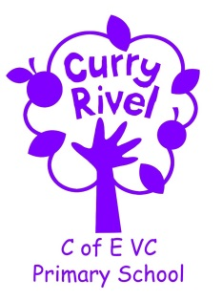
Little Pips Nursery

Information and Ideas
for your child’s next steps
Pre-School Year

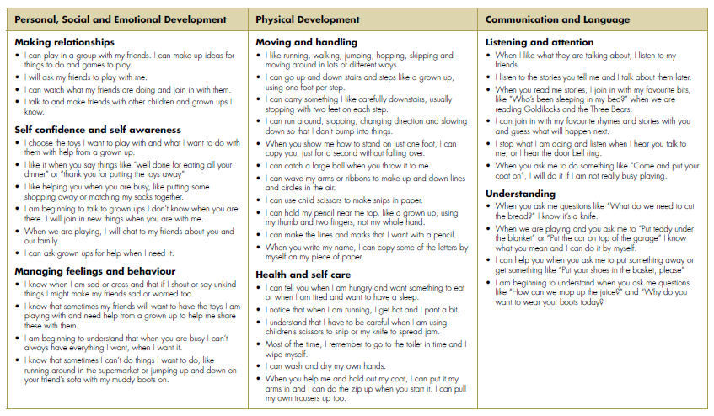
The Early Years Framework explains the next steps that a child will take at each stage. Each individual child develops different strengths at different times and this booklet will clarify what should happen next as your child progresses.

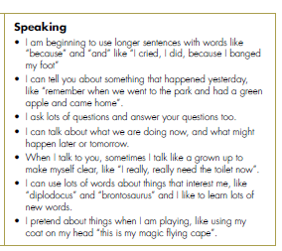

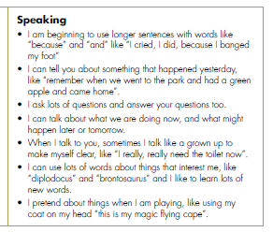
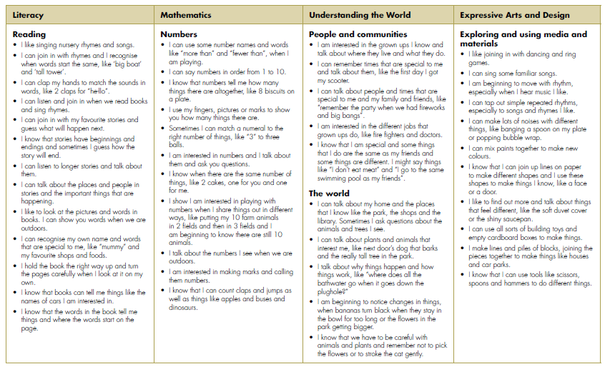

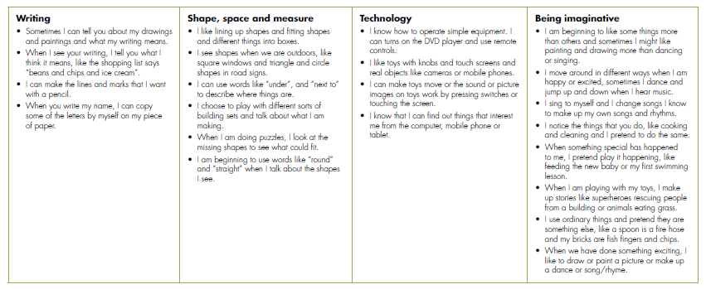

Communication and Language
Listening and attention
- Play listening games with me like “Simon Says…” where I have to copy an action or “Ready, Steady, Go” where I have to wait to push the ball or car.
- Make up silly sentences with me where each word begins with the same sound as the start of my name.
Speaking
- Talk to me about things we did or places that we went to yesterday.
Understanding
- When I’m helping you to make the lunch, ask me questions like “What do I need to cut the apple”? or “What do I need to pour your milk/water into? So that I can find you the thing we need.
- When we’re tidying up give me simple instructions like “Put your shoes in the basket” or “Put the remote control on the sofa”.

Literacy
Reading
- Set up a pretend shop where I can read the labels on the packets and boxes.
- Read a recipe to me as we’re making dough.
Writing
- Tell me what you’re writing as you write a shopping list.
- Make a name card for my bedroom door or a placemat with my name on. Let me use these to help me try to write my name by myself.
Mathematics
Numbers
- Make a train shed with numbers on so that I can match my trains into the shed with the same number on.
- Put numbers on a skittles game made from plastic bottles. Ask me what number was on the bottle I knocked down.
Shape, space and measure
- Let me build from cardboard boxes or wooden bricks. Use words like “long” or “tall” to describe my model.
- Go on a shape walk inside or outside to find things which are the same like “circles” or “spheres”.

How can you help your child?
Physical Development
Moving and handling
- Let me practice using children’s scissors to cut dough, cooked spaghetti or paper.
- Make an obstacle course in the park or garden where I have to run around benches or chairs, crawl under a blanket and crawl through a cardboard box.
Health and self-care
- Make sure I brush my teeth twice a day

Expressive Arts and Design
Exploring and using media and materials
- Let me use my paints to mix up my own colours.
Being imaginative
- Help me to use some of my toys to make up a story.
- Give me pieces of material to make a cape or a big cardboard box to make a spaceship when I’m pretending to be somebody else or going on an adventure.

How can you help your child?
Understanding the World
People and communities
- Take me out to different places where we live, like the fire station or the library.
The world
- Let me explore mud, rain or snow.
- Plant seeds with me in a pot or in the garden.
Technology
Let me press buttons, like on the pelican crossing or the doorbell at our friend’s house, to see what happens
Personal, Social and Emotional Development
Making relationships
- Let me build things with my friends using big cardboard boxes and pieces of fabric.
Self-confidence and self-awareness
- Let me help you match the socks together.
Managing feelings and behaviour
- Let me dress up and pretend to be a nurse, doctor, fire-fighter, mum or dad.
- Explain to me why I cannot do things like run around the supermarket.

